Bandwidth

📊 What Is Bandwidth in Networking?
# Source: AI Source: Provided by: [Data Path: Persons Table -> ID Column: 1, Name_En Column: Motasem Essam] -> From: [ChatGPT] on [12/18/2025]
Bandwidth refers to the maximum amount of data that can be transmitted over a network connection in a given amount of time. It's essentially the capacity of a network link.

📦 Belongs to:
# Source: AI Source: Provided by: [Data Path: Persons Table -> ID Column: 1, Name_En Column: Motasem Essam] -> From: [ChatGPT] on [12/18/2025]
✅ Network Performance Metrics
Alongside latency, throughput, and jitter.

🧠 Definition:
# Source: AI Source: Provided by: [Data Path: Persons Table -> ID Column: 1, Name_En Column: Motasem Essam] -> From: [ChatGPT] on [12/18/2025]
Bandwidth is the maximum rate at which data can be transferred from one point to another over a network — typically measured in bits per second (bps).

📏 Common Units of Bandwidth
# Source: AI Source: Provided by: [Data Path: Persons Table -> ID Column: 1, Name_En Column: Motasem Essam] -> From: [ChatGPT] on [12/18/2025]
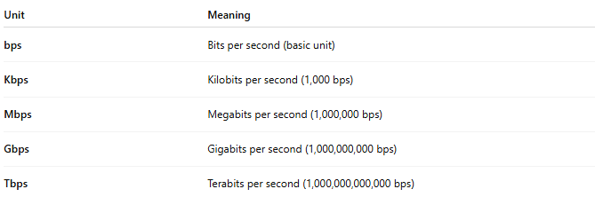
Unit | Meaning
bps | Bits per second (basic unit)
Kbps | Kilobits per second (1,000 bps)
Mbps | Megabits per second (1,000,000 bps)
Gbps | Gigabits per second (1,000,000,000 bps)
Tbps | Terabits per second (1,000,000,000,000 bps)

📡 Example Scenarios
# Source: AI Source: Provided by: [Data Path: Persons Table -> ID Column: 1, Name_En Column: Motasem Essam] -> From: [ChatGPT] on [12/18/2025]

Activity | Required Bandwidth (Approx.)
Web browsing | 1–5 Mbps
HD video streaming | 5–8 Mbps
4K video streaming | 15–25 Mbps
Online gaming | 3–6 Mbps
Video conferencing | 2–6 Mbps (per user)

🧮 Bandwidth vs Throughput vs Speed
# Source: AI Source: Provided by: [Data Path: Persons Table -> ID Column: 1, Name_En Column: Motasem Essam] -> From: [ChatGPT] on [12/18/2025]
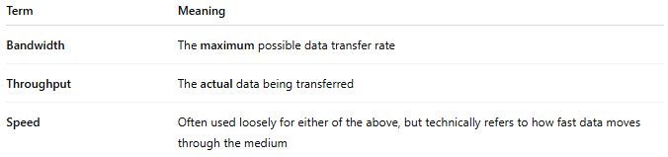
Term | Meaning
Bandwidth | The maximum possible data transfer rate
Throughput | The actual data being transferred
Speed | Often used loosely for either of the above, but technically refers to how fast data moves through the medium

✅ Why Bandwidth Matters
# Source: AI Source: Provided by: [Data Path: Persons Table -> ID Column: 1, Name_En Column: Motasem Essam] -> From: [ChatGPT] on [12/18/2025]
- 🚀 Higher bandwidth = more data per second
- 📶 Critical for streaming, downloads, VoIP, cloud apps
- 🔀 Needed to support multiple users or devices at once
- 📈 Impacts network performance and user experience

❌ Common Bandwidth Issues
# Source: AI Source: Provided by: [Data Path: Persons Table -> ID Column: 1, Name_En Column: Motasem Essam] -> From: [ChatGPT] on [12/18/2025]
- 🧱 Network congestion when demand exceeds capacity
- 🎮 Lag in games or video calls from limited bandwidth
- 📉 Slow downloads/uploads during peak times

📌 Summary
# Source: AI Source: Provided by: [Data Path: Persons Table -> ID Column: 1, Name_En Column: Motasem Essam] -> From: [ChatGPT] on [12/18/2025]
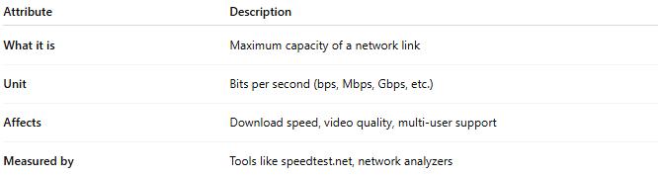

Attribute | Description
What it is | Maximum capacity of a network link
Unit | Bits per second (bps, Mbps, Gbps, etc.)
Affects | Download speed, video quality, multi-user support
Measured by | Tools like speedtest.net, network analyzers

